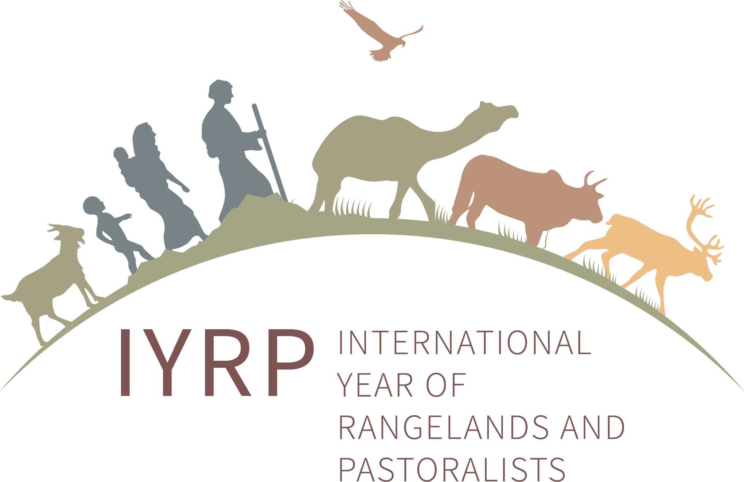
Guidance on letters of commitment/support for IYRP 2026
(updated November 2023)

The United Nations has designated 2026 to be the International Year of Rangelands and Pastoralists (IYRP 2026). Partners are encouraged to express support through letters that describe:
- the importance of IYRP to your government/organisation
- the types of activities you could carry out or participate in – both before and during the IYRP 2026
- an indicative amount of financing available from your organization, or the potential funding strategy for IYRP

Please address the letter to:
H.E. Mr Bolorchuluun Khayangaa
Minister of Food, Agriculture and Light Industry of Mongolia (MoFALI)
13381 Governmental Building 9th, Peace Avenue 16a,
Bayanzurkh District, Ulaanbaatar, Mongolia
info@mofa.gov.mn
Please copy the letter to:
- Munkhnasan Tsevegmed, Officer, MoFALI, and Secretary of Mongolia National Task Force for the IYRP (munkhnasan@mofa.gov.mn / munkhnasan2025@gmail.com)
- Gregorio Velasco-Gil, AGAG, FAO (gregorio.velascogil@fao.org)
- Igshaan Samuels, Co-Chair ISG for the IYRP (isamuels@uwc.ac.za)
Please also consider other ways to participate in the IYRP process, e.g. by:
- sharing the logo of your organisation to be placed on the IYRP ISG website (https://www.iyrp.info/friends-of-iyrp); if interested, please send your logos in high resolution to Ann Waters-Bayer (waters-bayer@web.de).
- joining the mailing group of the IYRP. Information about the IYRP is regularly but not frequently shared on this network mailing list; if interested, please contact Ann Waters-Bayer (waters-bayer@web.de) or Barbara Hutchinson (barbaraH@cals.arizona.edu).
- becoming an active member of the Regional IYRP Support Group (RISG) for your region or the region(s) you work in/with; if interested, please contact the respective Chairs of the RISGs, whose addresses can be found on this webpage: https://iyrp.info/resources/front

